**Conservation Reserve Program Water Quality Practices**

**Annual Report Fiscal Year 2023**

**FPAC Business Center/Economic and Policy Analysis Division in Collaboration with the Farm Service Agency**

**Background**

Section 2201 of the Agriculture Improvement Act of 2018 (the 2018 Farm Bill) requires that the Farm Service Agency publish an annual report of Conservation Reserve Program (CRP) summary statistics regarding conservation practices that have a positive impact on water quality to foster clean lakes, estuaries, and rivers (the CLEAR Initiative), including data on:

* New enrollments;
* Expirations;
* The geographic distribution of enrollment; and
* Estimated water quality benefits.

This report provides data on water quality practices and their impacts for fiscal year (FY) 2023. CRP conservation practices that have a positive impact on water quality include grass waterways, contour grass sod strips, filter strips, riparian buffers, wetlands or wetland buffers, saturated buffers, bioreactors, prairie strips, and other similar water quality practices.

**New Enrollments**

A total of 78,332 acres were newly enrolled across all CLEAR practices in FY 2023 (Table 1). These new enrollments account for 18 percent of all new CRP enrollments in FY 2023. Wetland restorations (CP23 and CP23A) accounted for 49 percent of new CLEAR enrollments. Duck nesting habitat (CP37) accounted for an additional 22 percent (Table 1).

**Table 1. New Enrollments FY 2023 (Acres) - Water Quality Practices**

|  |  |  |
| --- | --- | --- |
| **Practice Number** | **Practice Name** | **Acres1** |
| CP8A | Grass Waterways, Non-easement | 1,769 |
| CP9 | Shallow Water Areas for Wildlife | 253 |
| CP15A&B | Contour Grass Strips | 107 |
| CP21 | Filter Strips | 4,119 |
| CP21B | Denitrifying Bioreactor on Filter Strips | 5 |
| CP21S | Saturated Buffer Filter Strips | 26 |
| CP22 | Riparian Buffers | 2,823 |
| CP22B | Denitrifying Bioreactor on Riparian Buffers | 28 |
| CP22S | Saturated Buffer Riparian Buffers | 0 |
| CP23 | Wetland Restoration | 7,190 |
| CP23A | Wetland Restoration, Non-floodplain | 31,343 |
| CP29 | Marginal Pastureland Wildlife Habitat Buffer | 375 |
| CP30 | Marginal Pastureland Wetland Buffer | 211 |
| CP31 | Bottomland Timber Establishment on Wetlands | 3,944 |
| CP37 | Duck Nesting Habitat | 17,494 |
| CP38BUF | SAFE Buffers | 13 |
| CP38WET | SAFE Wetlands | 3,193 |
| CP43 | Prairie Strips | 5,438 |
| TOTAL WATER QUALITY PRACTICES2 | | 78,332 |
| 1 New enrollments in Signups 59 and 60 as of October 31, 2023.  2 Acres may not sum to total due to rounding. | | |

**Net Expirations**

Table 2 shows the number of CLEAR acres that expired in FY 2023, the expired acres that reenrolled, and net expirations across all water quality practices. A total of 201,288 acres expired and 101,913 acres were reenrolled across all CLEAR practices, for a net expiration of 99,374 acres. Bottomland timber establishment on wetlands (CP31) and non-floodplain wetland restoration (CP23A) had the highest reenrollment rates (at 90 percent and 72 percent, respectively), followed by shallow water areas for wildlife (CP9) and non-easement grass waterways (CP8A) (at 70 percent and 67 percent, respectively.)

**Table 2. Net Expirations FY 2023 (Acres) - Water Quality Practices**

|  |  |  |  |  |
| --- | --- | --- | --- | --- |
| **Practice Number** | **Practice Name** | **Expired Acres1** | **Reenrolled Acres2** | **Net Expirations** |
| CP8A | Grass Waterways, Non-easement | 11,055 | 7,414 | 3,641 |
| CP9 | Shallow Water Areas for Wildlife | 2,976 | 2,069 | 907 |
| CP15A | Contour Grass Strip | 6,562 | 498 | 6,064 |
| CP15B | Contour Grass Strips on Terraces | 320 | 211 | 109 |
| CP21 | Filter Strips | 43,827 | 26,508 | 17,319 |
| CP21B | Denitrifying Bioreactor on Filter Strips | 0 | 0 | 0 |
| CP21S | Saturated Buffer Filter Strips | 0 | 0 | 0 |
| CP22 | Riparian Buffers | 20,959 | 10,153 | 10,805 |
| CP22B | Denitrifying Bioreactor on Riparian Buffers | 0 | 0 | 0 |
| CP22S | Saturated Buffer Riparian Buffers | 0 | 0 | 0 |
| CP23 | Wetland Restoration | 39,066 | 12,735 | 26,331 |
| CP23A | Wetland Restoration, Non-floodplain | 22,215 | 16,053 | 6,162 |
| CP29 | Marginal Pastureland Wildlife Habitat Buffer | 10,823 | 1,046 | 9,778 |
| CP30 | Marginal Pastureland Wetland Buffer | 1,929 | 929 | 999 |
| CP31 | Bottomland Timber Establishment on Wetlands | 4,532 | 4,077 | 455 |
| CP37 | Duck Nesting Habitat | 32,258 | 20,138 | 12,120 |
| CP38BUF | SAFE Buffers | 0 | 0 | 0 |
| CP38WET | SAFE Wetlands | 4,765 | 82 | 4,683 |
| CP43 | Prairie Strips | 0 | 0 | 0 |
| TOTAL WATER QUALITY PRACTICES3 | | 201,288 | 101,913 | 99,374 |
| 1 Total acres expiring as of September 30, 2023.  2 Number of expiring acres that reenrolled as of October 31, 2023.  3 Acres may not sum to total due to rounding. | | | | |

**Geographic Distribution**

Figure 1 shows the geographic distribution of FY 2023 newly enrolled CLEAR acreage across the United States. The data for each water quality practice by state are shown in Appendix Table A1.

**Figure 1. New Enrollments FY 2023, Water Quality Practices**

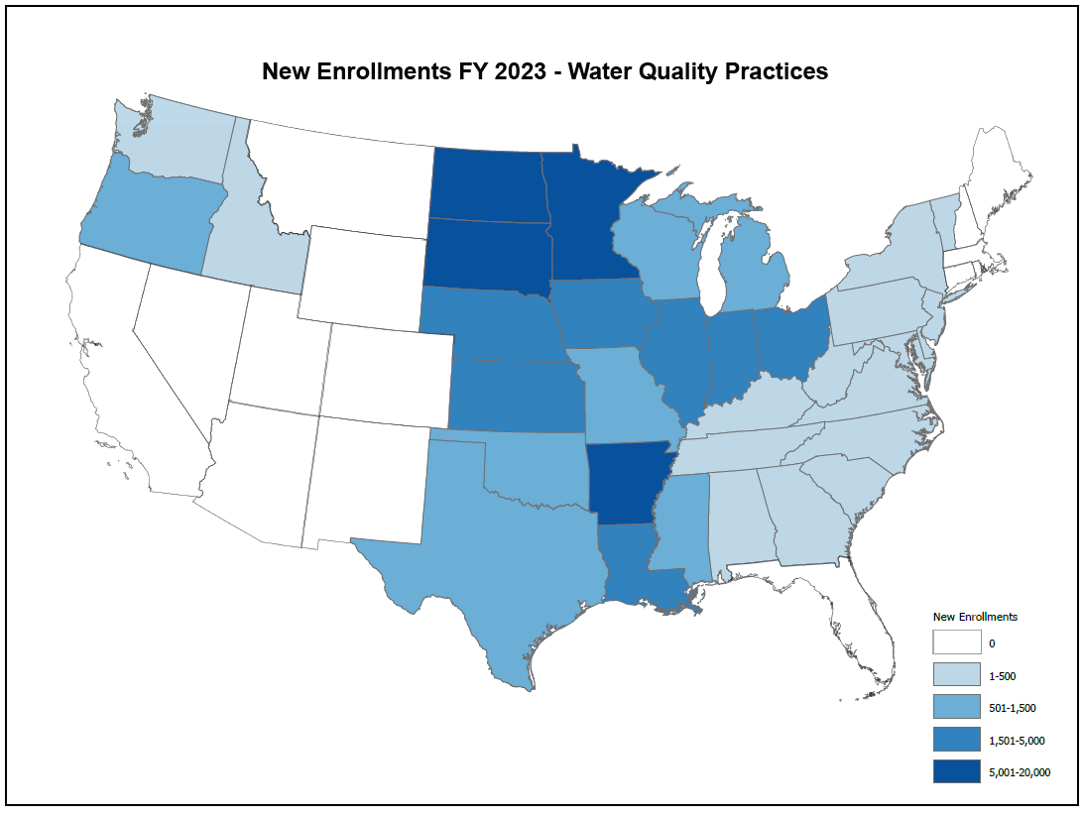

Figure 2 shows the geographic distribution of net expirations for all CLEAR practices in FY 2023. State-level data for net expired acres are shown in Appendix Table A2.

**Figure 2. Net Expirations FY 2023, Water Quality Practices**

Figure 3 shows the geographic distribution of the cumulative 3.26 million enrolled acres in all CLEAR practices (including CLEAR 30) as of FY 2023. (CLEAR 30 is a pilot that enables enrollment in a 30-year CRP contract for certain water quality practices expiring under continuous signup.) State-level data for total cumulative enrolled acres, including CLEAR 30, are shown in Appendix Table A3.

**Figure 3. Total Cumulative Enrollment FY 2023, Water Quality Practices**

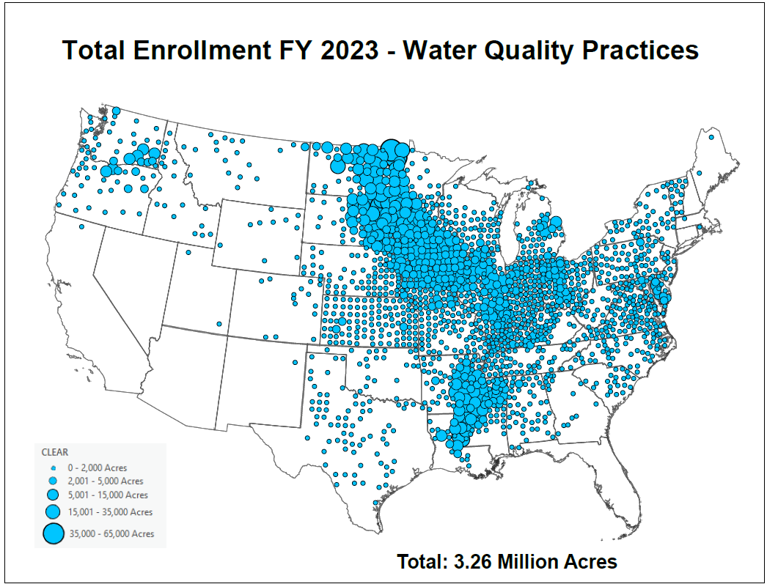

**Comparison of CLEAR Practices to Non-CLEAR Practices for Continuous Sign-Ups**

The 2018 Farm Bill stipulates that, to the maximum extent practicable, not less than 40 percent of the acres enrolled in CRP under continuous signup shall be CLEAR acres. At the end of FY 2023, 40 percent of total continuous acres were in CLEAR practices. For the continuous sign-up held during FY 2023, CLEAR practices accounted for 26 percent.

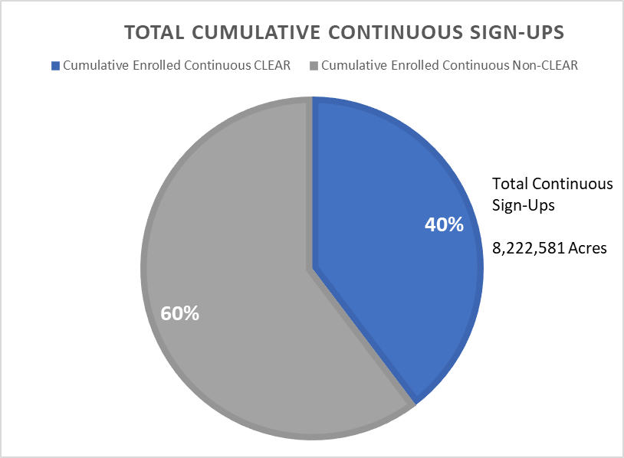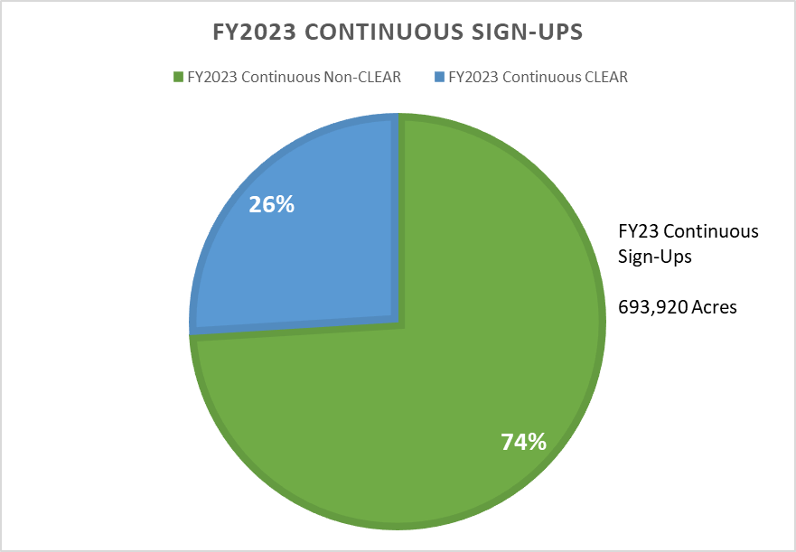**Figure 4. Proportion of CLEAR Practice Acres Enrolled Comparison to Total Cumulative Continuous Sign-ups Through FY 2023 and CLEAR Practice Enrollment that Occurred in FY 2023.**

**Estimated Water Quality Benefits**

CRP CLEAR practices reduce the amount of sediments and nutrients leaving a field in runoff and percolate, leading to water quality benefits. CLEAR practice impacts are based on Agricultural Policy/Environmental eXtender (APEX) model simulations at a representative sample of CLEAR practice locations.

The current estimation approach represents a significant improvement over the previous one, which was based on APEX’s predecessor, the Environmental Policy Integrated Climate (EPIC) model, and on the 363 dominant soil types on CRP-enrolled land, rather than 27,000 actual practice locations[1]. Further, only a generic sediment-trapping practice was considered in the prior model, as opposed to modeling six CLEAR practice types explicitly in the new model.

Nitrogen, phosphorus, and sediment reductions at the edge-of-field are estimated as the difference between with- and without-practice scenarios model outputs at each location. The APEX scenarios assume practice configuration and treatment area at each location to be adequately represented by an idealized field. Scenario crop rotations at each location are assigned using survey data collected for the Conservation Effects Assessment Project (CEAP) cropland assessment. Based on model results, mean unit values are calculated for each practice and CEAP production region, applied to the practice acres enrolled in a given year in the respective region, and summed.[2]

Table 3 shows estimated water quality benefits for the 3.26 million CLEAR practice acres enrolled in FY 2023. As compared to a cropped scenario, CLEAR practices reduced nutrient losses by an estimated 361 million pounds of nitrogen and 79 million pounds of phosphorus in FY 2023. CLEAR practices reduced sedimentation by 128 million tons in FY 2023.

**Table 3. Estimated Water Quality Benefits, FY 2023**

|  |  |
| --- | --- |
| **Reductions (Not leaving field or intercepted by buffers)** | |
| Sediment (million tons) | 128 |
| Nitrogen (million lbs.) | 361 |
| Phosphorous (million lbs.) | 79 |

In addition to satisfying Farm Bill reporting requirements, these estimates help producers contemplating enrollment decisions. They also quantify for the public how the program achieves measurable results on the landscape. This information is not only useful to FSA, but also to Conservation Reserve Enhancement Program (CREP), State Acres for Wildlife Enhancement (SAFE), and other conservation partners striving to increase program participation and achieve clean lakes, estuaries, and rivers.

**Appendix Table A1. New Enrollments FY 2023 (Acres) - Water Quality Practices, by State**

|  |  |  |  |  |  |  |  |
| --- | --- | --- | --- | --- | --- | --- | --- |
| **STATE** | **GRASS WATER-WAYS (CP8)** | **SHALLOW WATER AREAS FOR WILDLIFE (CP9)** | **CONTOUR GRASS STRIPS (CP15A)** | **CONTOUR GRASS STRIPS (CP15B)** | **FILTER-STRIPS (CP21)** | **DENITRIFYING BIOREACTOR ON FILTER STRIPS (CP21B)** | **SATURATED FILTER-STRIPS (CP21S)** |
| ALABAMA | 0 | 0 | 0 | 0 | 0 | 0 | 0 |
| ALASKA | 0 | 0 | 0 | 0 | 0 | 0 | 0 |
| ARIZONA | 0 | 0 | 0 | 0 | 0 | 0 | 0 |
| ARKANSAS | 0 | 10 | 0 | 0 | 0 | 0 | 0 |
| CALIFORNIA | 0 | 0 | 0 | 0 | 0 | 0 | 0 |
| COLORADO | 0 | 0 | 0 | 0 | 0 | 0 | 0 |
| CONNECTICUT | 0 | 0 | 0 | 0 | 0 | 0 | 0 |
| DELAWARE | 0 | 0 | 0 | 0 | 0 | 0 | 0 |
| FLORIDA | 0 | 0 | 0 | 0 | 0 | 0 | 0 |
| GEORGIA | 0 | 0 | 0 | 0 | 0 | 0 | 0 |
| HAWAII | 0 | 0 | 0 | 0 | 0 | 0 | 0 |
| IDAHO | 0 | 10 | 0 | 0 | 0 | 0 | 0 |
| ILLINOIS | 146 | 48 | 1 | 0 | 378 | 0 | 0 |
| INDIANA | 293 | 20 | 0 | 0 | 284 | 0 | 0 |
| IOWA | 283 | 71 | 8 | 0 | 897 | 1 | 26 |
| KANSAS | 68 | 0 | 0 | 14 | 81 | 0 | 0 |
| KENTUCKY | 117 | 0 | 0 | 0 | 137 | 0 | 0 |
| LOUISIANA | 0 | 0 | 0 | 0 | 0 | 0 | 0 |
| MAINE | 0 | 0 | 0 | 0 | 0 | 0 | 0 |
| MARYLAND | 0 | 11 | 0 | 0 | 22 | 0 | 0 |
| MASSACHUSETTS | 0 | 0 | 0 | 0 | 0 | 0 | 0 |
| MICHIGAN | 6 | 8 | 0 | 0 | 60 | 0 | 0 |
| MINNESOTA | 39 | 0 | 12 | 0 | 381 | 3 | 0 |
| MISSISSIPPI | 0 | 0 | 0 | 0 | 27 | 0 | 0 |
| MISSOURI | 9 | 10 | 0 | 5 | 122 | 0 | 0 |
| MONTANA | 0 | 0 | 0 | 0 | 0 | 0 | 0 |
| NEBRASKA | 29 | 0 | 0 | 0 | 142 | 0 | 0 |
| NEVADA | 0 | 0 | 0 | 0 | 0 | 0 | 0 |
| NEW HAMPSHIRE | 0 | 0 | 0 | 0 | 0 | 0 | 0 |
| NEW JERSEY | 1 | 0 | 0 | 0 | 3 | 0 | 0 |
| NEW MEXICO | 0 | 0 | 0 | 0 | 0 | 0 | 0 |
| NEW YORK | 0 | 0 | 0 | 0 | 10 | 0 | 0 |
| NORTH CAROLINA | 0 | 0 | 0 | 0 | 3 | 0 | 0 |
| NORTH DAKOTA | 0 | 0 | 0 | 0 | 64 | 0 | 0 |
| OHIO | 615 | 14 | 0 | 0 | 606 | 0 | 0 |
| OKLAHOMA | 0 | 0 | 0 | 0 | 0 | 0 | 0 |
| OREGON | 0 | 0 | 0 | 0 | 81 | 0 | 0 |
| PENNSYLVANIA | 1 | 0 | 0 | 0 | 4 | 0 | 0 |
| PUERTO RICO | 0 | 0 | 0 | 0 | 0 | 0 | 0 |
| RHODE ISLAND | 0 | 0 | 0 | 0 | 0 | 0 | 0 |
| SOUTH CAROLINA | 0 | 0 | 0 | 0 | 0 | 0 | 0 |
| SOUTH DAKOTA | 24 | 0 | 0 | 0 | 283 | 0 | 0 |
| TENNESSEE | 0 | 19 | 0 | 0 | 20 | 0 | 0 |
| TEXAS | 3 | 0 | 10 | 57 | 0 | 0 | 0 |
| UTAH | 0 | 0 | 0 | 0 | 0 | 0 | 0 |
| VERMONT | 0 | 0 | 0 | 0 | 0 | 0 | 0 |
| VIRGINIA | 0 | 0 | 0 | 0 | 3 | 0 | 0 |
| WASHINGTON | 126 | 0 | 0 | 0 | 21 | 0 | 0 |
| WEST VIRGINIA | 0 | 0 | 0 | 0 | 11 | 0 | 0 |
| WISCONSIN | 8 | 33 | 0 | 0 | 479 | 0 | 0 |
| WYOMING | 0 | 0 | 0 | 0 | 0 | 0 | 0 |
| TOTAL | 1,769 | 253 | 31 | 76 | 4,119 | 5 | 26 |

**Appendix Table A1. New Enrollments FY 2023 (Acres) - Water Quality Practices, by State**

|  |  |  |  |  |  |  |  |
| --- | --- | --- | --- | --- | --- | --- | --- |
| **STATE** | **RIPARIAN BUFFERS (CP22)** | **DENITRIFYING BIOREACTOR ON RIPARIAN BUFFERS (CP22B)** | **SATURATED BUFFER RIPARIAN BUFFERS (CP22S)** | **WETLAND RESTORATION (CP23)** | **WETLAND RESTORATION NON-FLOODPLAIN (CP23A)** | **MARGINAL PASTURE BUFFERS-WILDLIFE (CP29)** | **MARGINAL PASTURE BUFFERS-WETLAND (CP30)** |
| ALABAMA | 91 | 0 | 0 | 0 | 0 | 0 | 0 |
| ALASKA | 0 | 0 | 0 | 0 | 0 | 0 | 0 |
| ARIZONA | 0 | 0 | 0 | 0 | 0 | 0 | 0 |
| ARKANSAS | 126 | 0 | 0 | 3,322 | 2,190 | 0 | 0 |
| CALIFORNIA | 0 | 0 | 0 | 0 | 0 | 0 | 0 |
| COLORADO | 0 | 0 | 0 | 0 | 0 | 0 | 0 |
| CONNECTICUT | 0 | 0 | 0 | 0 | 0 | 0 | 0 |
| DELAWARE | 1 | 0 | 0 | 0 | 0 | 0 | 0 |
| FLORIDA | 0 | 0 | 0 | 0 | 0 | 0 | 0 |
| GEORGIA | 10 | 0 | 0 | 0 | 0 | 0 | 0 |
| HAWAII | 0 | 0 | 0 | 0 | 0 | 0 | 0 |
| IDAHO | 0 | 0 | 0 | 0 | 0 | 0 | 0 |
| ILLINOIS | 466 | 6 | 0 | 107 | 249 | 0 | 0 |
| INDIANA | 34 | 0 | 0 | 131 | 418 | 0 | 0 |
| IOWA | 160 | 5 | 0 | 544 | 276 | 25 | 31 |
| KANSAS | 3 | 0 | 0 | 193 | 59 | 0 | 0 |
| KENTUCKY | 6 | 0 | 0 | 0 | 0 | 22 | 0 |
| LOUISIANA | 0 | 0 | 0 | 246 | 1,577 | 0 | 0 |
| MAINE | 0 | 0 | 0 | 0 | 0 | 0 | 0 |
| MARYLAND | 36 | 0 | 0 | 25 | 38 | 0 | 0 |
| MASSACHUSETTS | 0 | 0 | 0 | 0 | 0 | 0 | 0 |
| MICHIGAN | 0 | 0 | 0 | 151 | 626 | 0 | 0 |
| MINNESOTA | 126 | 0 | 0 | 663 | 14,612 | 0 | 37 |
| MISSISSIPPI | 352 | 0 | 0 | 0 | 14 | 0 | 0 |
| MISSOURI | 24 | 0 | 0 | 554 | 191 | 9 | 0 |
| MONTANA | 0 | 0 | 0 | 0 | 0 | 0 | 0 |
| NEBRASKA | 9 | 3 | 0 | 225 | 42 | 0 | 0 |
| NEVADA | 0 | 0 | 0 | 0 | 0 | 0 | 0 |
| NEW HAMPSHIRE | 0 | 0 | 0 | 0 | 0 | 0 | 0 |
| NEW JERSEY | 8 | 0 | 0 | 0 | 0 | 0 | 0 |
| NEW MEXICO | 0 | 0 | 0 | 0 | 0 | 0 | 0 |
| NEW YORK | 38 | 0 | 0 | 0 | 0 | 0 | 28 |
| NORTH CAROLINA | 0 | 0 | 0 | 0 | 0 | 0 | 0 |
| NORTH DAKOTA | 0 | 0 | 0 | 138 | 4,716 | 0 | 0 |
| OHIO | 134 | 0 | 0 | 147 | 818 | 7 | 0 |
| OKLAHOMA | 0 | 0 | 0 | 0 | 0 | 0 | 0 |
| OREGON | 442 | 0 | 0 | 0 | 0 | 30 | 0 |
| PENNSYLVANIA | 137 | 0 | 0 | 0 | 0 | 7 | 13 |
| PUERTO RICO | 0 | 0 | 0 | 0 | 0 | 0 | 0 |
| RHODE ISLAND | 0 | 0 | 0 | 0 | 0 | 0 | 0 |
| SOUTH CAROLINA | 330 | 7 | 0 | 0 | 0 | 0 | 0 |
| SOUTH DAKOTA | 20 | 0 | 0 | 677 | 4,959 | 273 | 102 |
| TENNESSEE | 4 | 0 | 0 | 26 | 0 | 2 | 0 |
| TEXAS | 0 | 0 | 0 | 0 | 476 | 0 | 0 |
| UTAH | 0 | 0 | 0 | 0 | 0 | 0 | 0 |
| VERMONT | 47 | 0 | 0 | 0 | 0 | 0 | 0 |
| VIRGINIA | 165 | 0 | 0 | 0 | 0 | 0 | 0 |
| WASHINGTON | 4 | 0 | 0 | 0 | 0 | 0 | 0 |
| WEST VIRGINIA | 42 | 0 | 0 | 0 | 0 | 0 | 0 |
| WISCONSIN | 8 | 7 | 0 | 40 | 83 | 0 | 0 |
| WYOMING | 0 | 0 | 0 | 0 | 0 | 0 | 0 |
| TOTAL | 2,823 | 28 | 0 | 7,190 | 31,343 | 375 | 211 |

**Appendix Table A1. New Enrollments FY 2023 (Acres) - Water Quality Practices, by State**

|  |  |  |  |  |  |  |
| --- | --- | --- | --- | --- | --- | --- |
| **STATE** | **BOTTOMLAND HARDWOOD TREES (CP31)** | **DUCK NESTING HABITAT (CP37)** | **SAFE BUFFERS (CP38BUF)** | **SAFE WETLANDS (CP38WET)** | **PRAIRIE STRIPS (CP43)** | **ALL WATER QUALITY PRACTICES** |
| ALABAMA | 0 | 0 | 0 | 0 | 0 | 91 |
| ALASKA | 0 | 0 | 0 | 0 | 0 | 0 |
| ARIZONA | 0 | 0 | 0 | 0 | 0 | 0 |
| ARKANSAS | 1,008 | 0 | 0 | 0 | 0 | 6,656 |
| CALIFORNIA | 0 | 0 | 0 | 0 | 0 | 0 |
| COLORADO | 0 | 0 | 0 | 0 | 0 | 0 |
| CONNECTICUT | 0 | 0 | 0 | 0 | 0 | 0 |
| DELAWARE | 0 | 0 | 0 | 0 | 0 | 1 |
| FLORIDA | 0 | 0 | 0 | 0 | 0 | 0 |
| GEORGIA | 0 | 0 | 0 | 0 | 0 | 10 |
| HAWAII | 0 | 0 | 0 | 0 | 0 | 0 |
| IDAHO | 0 | 0 | 0 | 0 | 0 | 10 |
| ILLINOIS | 490 | 0 | 13 | 24 | 916 | 2,843 |
| INDIANA | 171 | 0 | 0 | 0 | 218 | 1,570 |
| IOWA | 362 | 456 | 0 | 0 | 974 | 4,122 |
| KANSAS | 0 | 0 | 0 | 1,449 | 11 | 1,879 |
| KENTUCKY | 85 | 0 | 0 | 0 | 0 | 368 |
| LOUISIANA | 1,120 | 0 | 0 | 0 | 0 | 2,943 |
| MAINE | 0 | 0 | 0 | 0 | 0 | 0 |
| MARYLAND | 0 | 0 | 0 | 0 | 2 | 135 |
| MASSACHUSETTS | 0 | 0 | 0 | 0 | 0 | 0 |
| MICHIGAN | 0 | 0 | 0 | 0 | 53 | 905 |
| MINNESOTA | 0 | 850 | 0 | 0 | 568 | 17,292 |
| MISSISSIPPI | 570 | 0 | 0 | 0 | 0 | 963 |
| MISSOURI | 110 | 0 | 0 | 0 | 288 | 1,322 |
| MONTANA | 0 | 0 | 0 | 0 | 0 | 0 |
| NEBRASKA | 0 | 0 | 0 | 378 | 1,933 | 2,762 |
| NEVADA | 0 | 0 | 0 | 0 | 0 | 0 |
| NEW HAMPSHIRE | 0 | 0 | 0 | 0 | 0 | 0 |
| NEW JERSEY | 0 | 0 | 0 | 0 | 0 | 11 |
| NEW MEXICO | 0 | 0 | 0 | 0 | 0 | 0 |
| NEW YORK | 0 | 0 | 0 | 0 | 0 | 76 |
| NORTH CAROLINA | 0 | 0 | 0 | 0 | 0 | 3 |
| NORTH DAKOTA | 0 | 3,579 | 0 | 460 | 0 | 8,957 |
| OHIO | 0 | 0 | 0 | 0 | 59 | 2,400 |
| OKLAHOMA | 0 | 0 | 0 | 671 | 0 | 671 |
| OREGON | 0 | 0 | 0 | 0 | 0 | 553 |
| PENNSYLVANIA | 0 | 0 | 0 | 0 | 0 | 162 |
| PUERTO RICO | 0 | 0 | 0 | 0 | 0 | 0 |
| RHODE ISLAND | 0 | 0 | 0 | 0 | 0 | 0 |
| SOUTH CAROLINA | 0 | 0 | 0 | 0 | 0 | 337 |
| SOUTH DAKOTA | 0 | 12,608 | 0 | 211 | 244 | 19,400 |
| TENNESSEE | 27 | 0 | 0 | 0 | 169 | 268 |
| TEXAS | 0 | 0 | 0 | 0 | 0 | 546 |
| UTAH | 0 | 0 | 0 | 0 | 0 | 0 |
| VERMONT | 0 | 0 | 0 | 0 | 0 | 47 |
| VIRGINIA | 0 | 0 | 0 | 0 | 0 | 167 |
| WASHINGTON | 0 | 0 | 0 | 0 | 0 | 151 |
| WEST VIRGINIA | 0 | 0 | 0 | 0 | 0 | 53 |
| WISCONSIN | 0 | 0 | 0 | 0 | 2 | 659 |
| WYOMING | 0 | 0 | 0 | 0 | 0 | 0 |
| TOTAL | 3,944 | 17,494 | 13 | 3,193 | 5,438 | 78,332 |

**Appendix Table A2. Net Expirations FY 2023 (Acres) - Water Quality Practices, by State**

|  |  |  |  |  |  |  |  |
| --- | --- | --- | --- | --- | --- | --- | --- |
| **STATE** | **GRASS WATERWAYS (CP8)** | **SHALLOW WATER AREAS FOR WILDLIFE (CP9)** | **CONTOUR GRASS STRIPS (CP15A)** | **CONTOUR GRASS STRIPS (CP15B)** | **FILTER-STRIPS (CP21)** | **RIPARIAN BUFFERS (CP22)** | **WETLAND RESTORATION (CP23)** |
| ALABAMA | 0 | 0 | 0 | 0 | 0 | 344 | 0 |
| ALASKA | 0 | 0 | 0 | 0 | 0 | 50 | 0 |
| ARIZONA | 0 | 0 | 0 | 0 | 0 | 0 | 0 |
| ARKANSAS | 5 | 5 | 0 | 0 | 314 | 1,321 | 30 |
| CALIFORNIA | 0 | 0 | 0 | 0 | 0 | 0 | 0 |
| COLORADO | 0 | 0 | 0 | 0 | 0 | 0 | 0 |
| CONNECTICUT | 0 | 0 | 0 | 0 | 0 | 0 | 0 |
| DELAWARE | 0 | 0 | 0 | 0 | 60 | 0 | 0 |
| FLORIDA | 0 | 0 | 0 | 0 | 0 | 0 | 0 |
| GEORGIA | 0 | 0 | 0 | 0 | 71 | 66 | 23 |
| HAWAII | 0 | 0 | 0 | 0 | 0 | 0 | 0 |
| IDAHO | 0 | 10 | 18 | 0 | 32 | 0 | 0 |
| ILLINOIS | 613 | 154 | 7 | 3 | 2,484 | 583 | 42 |
| INDIANA | 671 | 48 | 1 | 0 | 1,235 | 139 | 145 |
| IOWA | 1,105 | 233 | 223 | 8 | 3,685 | 736 | 1,949 |
| KANSAS | 280 | 35 | 17 | 74 | 624 | 62 | 89 |
| KENTUCKY | 171 | 65 | 0 | 0 | 401 | 806 | 0 |
| LOUISIANA | 0 | 33 | 0 | 0 | 0 | 0 | 332 |
| MAINE | 2 | 0 | 0 | 0 | 0 | 0 | 0 |
| MARYLAND | 7 | 27 | 0 | 0 | 1,325 | 160 | 6 |
| MASSACHUSETTS | 0 | 0 | 0 | 0 | 0 | 0 | 0 |
| MICHIGAN | 39 | 82 | 0 | 0 | 641 | 62 | 127 |
| MINNESOTA | 107 | 0 | 38 | 0 | 1,156 | 281 | 11,566 |
| MISSISSIPPI | 0 | 8 | 0 | 0 | 151 | 827 | 170 |
| MISSOURI | 102 | 81 | 85 | 0 | 1,088 | 284 | 152 |
| MONTANA | 3 | 0 | 0 | 0 | 0 | 52 | 287 |
| NEBRASKA | 64 | 23 | 9 | 25 | 462 | 60 | 15 |
| NEVADA | 0 | 0 | 0 | 0 | 0 | 0 | 0 |
| NEW HAMPSHIRE | 0 | 0 | 0 | 0 | 0 | 0 | 0 |
| NEW JERSEY | 5 | 0 | 0 | 0 | 8 | 20 | 0 |
| NEW MEXICO | 0 | 0 | 0 | 0 | 0 | 0 | 0 |
| NEW YORK | 3 | 0 | 0 | 0 | 2 | 232 | 2 |
| NORTH CAROLINA | 21 | 21 | 0 | 0 | 18 | 68 | 0 |
| NORTH DAKOTA | 5 | 0 | 0 | 0 | 142 | 9 | 6,520 |
| OHIO | 256 | 30 | 8 | 0 | 1,505 | 103 | 231 |
| OKLAHOMA | 17 | 0 | 0 | 0 | 50 | 26 | 0 |
| OREGON | 0 | 0 | 0 | 0 | 74 | 688 | 0 |
| PENNSYLVANIA | 7 | 0 | 0 | 0 | 15 | 703 | 0 |
| PUERTO RICO | 0 | 0 | 60 | 0 | 0 | 0 | 0 |
| RHODE ISLAND | 0 | 0 | 0 | 0 | 0 | 0 | 0 |
| SOUTH CAROLINA | 0 | 0 | 0 | 0 | 100 | 1,326 | 151 |
| SOUTH DAKOTA | 16 | 0 | 0 | 0 | 210 | 75 | 2,768 |
| TENNESSEE | 2 | 0 | 0 | 0 | 89 | 45 | 43 |
| TEXAS | 48 | 0 | 10 | 0 | 1 | 395 | 1,486 |
| UTAH | 0 | 0 | 0 | 0 | 0 | 0 | 0 |
| VERMONT | 0 | 0 | 0 | 0 | 3 | 149 | 0 |
| VIRGINIA | 6 | 0 | 0 | 0 | 42 | 442 | 0 |
| WASHINGTON | 47 | 2 | 5,583 | 0 | 1,013 | 318 | 0 |
| WEST VIRGINIA | 0 | 0 | 0 | 0 | 0 | 140 | 0 |
| WISCONSIN | 39 | 52 | 6 | 0 | 314 | 77 | 197 |
| WYOMING | 0 | 0 | 0 | 0 | 0 | 155 | 0 |
| TOTAL | 3,641 | 907 | 6,064 | 109 | 17,319 | 10,805 | 26,331 |

**Appendix Table A2. Net Expirations FY 2023 (Acres) - Water Quality Practices, by State**

|  |  |  |  |  |  |  |  |  |
| --- | --- | --- | --- | --- | --- | --- | --- | --- |
| **STATE** | **WETLAND RESTORATION NON-FLOODPLAIN (CP23A)** | **MARGINAL PASTURE BUFFERS-WILDLIFE (CP29)** | **MARGINAL PASTURE BUFFERS-WETLAND (CP30)** | **BOTTOMLAND HARDWOOD TREES (CP31)** | **DUCK NESTING HABITAT (CP37)** | **SAFE WETLANDS (CP38WET)** | **SAFE BUFFERS (CP38BUF)** | **ALL WATER QUALITY PRACTICES** |
| ALABAMA | 0 | 0 | 0 | 2 | 0 | 0 | 0 | 346 |
| ALASKA | 0 | 0 | 0 | 0 | 0 | 0 | 0 | 50 |
| ARIZONA | 0 | 0 | 0 | 0 | 0 | 0 | 0 | 0 |
| ARKANSAS | 124 | 16 | 0 | 161 | 0 | 3,619 | 0 | 5,595 |
| CALIFORNIA | 0 | 0 | 0 | 0 | 0 | 0 | 0 | 0 |
| COLORADO | 27 | 0 | 32 | 0 | 0 | 0 | 0 | 59 |
| CONNECTICUT | 0 | 0 | 0 | 0 | 0 | 0 | 0 | 0 |
| DELAWARE | 0 | 0 | 0 | 0 | 0 | 0 | 0 | 60 |
| FLORIDA | 0 | 0 | 0 | 0 | 0 | 0 | 0 | 0 |
| GEORGIA | 0 | 0 | 0 | 0 | 0 | 0 | 0 | 161 |
| HAWAII | 0 | 0 | 0 | 0 | 0 | 0 | 0 | 0 |
| IDAHO | 0 | 5 | 0 | 0 | 0 | 0 | 0 | 64 |
| ILLINOIS | 179 | 0 | 0 | 43 | 0 | 3 | 0 | 4,110 |
| INDIANA | 185 | 2 | 0 | 24 | 0 | 141 | 0 | 2,591 |
| IOWA | 186 | 120 | 8 | 72 | 19 | 183 | 0 | 8,526 |
| KANSAS | 186 | 0 | 0 | 9 | 0 | 0 | 0 | 1,377 |
| KENTUCKY | 0 | 8,772 | 0 | 0 | 0 | 46 | 0 | 10,261 |
| LOUISIANA | 0 | 0 | 0 | 37 | 0 | 261 | 0 | 662 |
| MAINE | 0 | 0 | 0 | 0 | 0 | 0 | 0 | 2 |
| MARYLAND | 0 | 8 | 0 | 0 | 0 | 0 | 0 | 1,533 |
| MASSACHUSETTS | 0 | 0 | 0 | 0 | 0 | 0 | 0 | 0 |
| MICHIGAN | 353 | 0 | 5 | 0 | 0 | 0 | 0 | 1,310 |
| MINNESOTA | 1,986 | 0 | 128 | 0 | 206 | 0 | 0 | 15,468 |
| MISSISSIPPI | 0 | 0 | 0 | 31 | 0 | 0 | 0 | 1,187 |
| MISSOURI | 23 | 112 | 12 | 35 | 0 | 0 | 0 | 1,973 |
| MONTANA | 0 | 0 | 0 | 0 | 72 | 22 | 0 | 436 |
| NEBRASKA | 28 | 48 | 10 | 9 | 0 | 0 | 0 | 754 |
| NEVADA | 0 | 0 | 0 | 0 | 0 | 0 | 0 | 0 |
| NEW HAMPSHIRE | 0 | 0 | 0 | 0 | 0 | 0 | 0 | 0 |
| NEW JERSEY | 0 | 0 | 0 | 0 | 0 | 0 | 0 | 32 |
| NEW MEXICO | 0 | 0 | 0 | 0 | 0 | 0 | 0 | 0 |
| NEW YORK | 0 | 78 | 31 | 0 | 0 | 0 | 0 | 349 |
| NORTH CAROLINA | 0 | 0 | 0 | 13 | 0 | 0 | 0 | 141 |
| NORTH DAKOTA | 68 | 35 | 0 | 0 | 8,875 | 102 | 0 | 15,757 |
| OHIO | 72 | 89 | 18 | 0 | 0 | 30 | 0 | 2,342 |
| OKLAHOMA | 0 | 0 | 0 | 0 | 0 | 0 | 0 | 93 |
| OREGON | 0 | 24 | 0 | 0 | 0 | 0 | 0 | 786 |
| PENNSYLVANIA | 0 | 15 | 3 | 0 | 0 | 0 | 0 | 744 |
| PUERTO RICO | 0 | 0 | 0 | 0 | 0 | 0 | 0 | 60 |
| RHODE ISLAND | 0 | 0 | 0 | 0 | 0 | 0 | 0 | 0 |
| SOUTH CAROLINA | 0 | 0 | 0 | 0 | 0 | 0 | 0 | 1,577 |
| SOUTH DAKOTA | 2,702 | 14 | 739 | 0 | 2,947 | 272 | 0 | 9,743 |
| TENNESSEE | 0 | 14 | 0 | 19 | 0 | 0 | 0 | 211 |
| TEXAS | 0 | 98 | 0 | 0 | 0 | 0 | 0 | 2,037 |
| UTAH | 0 | 0 | 0 | 0 | 0 | 0 | 0 | 0 |
| VERMONT | 0 | 0 | 1 | 0 | 0 | 0 | 0 | 153 |
| VIRGINIA | 0 | 24 | 0 | 0 | 0 | 0 | 0 | 515 |
| WASHINGTON | 0 | 119 | 12 | 0 | 0 | 0 | 0 | 7,094 |
| WEST VIRGINIA | 0 | 0 | 0 | 0 | 0 | 0 | 0 | 140 |
| WISCONSIN | 43 | 2 | 0 | 0 | 0 | 2 | 0 | 732 |
| WYOMING | 0 | 185 | 0 | 0 | 0 | 0 | 0 | 340 |
| TOTAL | 6,162 | 9,778 | 999 | 455 | 12,120 | 4,683 | 0 | 99,374 |

**Appendix Table A3. Cumulative Acres FY 2023 - Water Quality Practices, by State**

|  |  |  |  |
| --- | --- | --- | --- |
| **STATE** | **Regular CLEAR** | **CLEAR 30 1/** | **Total Water Quality Acres** |
| ALABAMA | 19,900 | 139 | 20,039 |
| ALASKA | 50 | 0 | 50 |
| ARIZONA | 0 | 0 | 0 |
| ARKANSAS | 145,553 | 3,499 | 149,052 |
| CALIFORNIA | 49 | 0 | 49 |
| COLORADO | 2,074 | 0 | 2,074 |
| CONNECTICUT | 0 | 0 | 0 |
| DELAWARE | 742 | 0 | 742 |
| FLORIDA | 0 | 0 | 0 |
| GEORGIA | 797 | 1 | 797 |
| HAWAII | 1,255 | 0 | 1,255 |
| IDAHO | 3,593 | 0 | 3,593 |
| ILLINOIS | 273,841 | 2,661 | 276,502 |
| INDIANA | 80,046 | 725 | 80,771 |
| IOWA | 386,107 | 2,221 | 388,327 |
| KANSAS | 40,468 | 289 | 40,756 |
| KENTUCKY | 39,661 | 1,453 | 41,113 |
| LOUISIANA | 211,227 | 6,835 | 218,062 |
| MAINE | 48 | 0 | 48 |
| MARYLAND | 31,935 | 25 | 31,960 |
| MASSACHUSETTS | 9 | 0 | 9 |
| MICHIGAN | 33,571 | 204 | 33,776 |
| MINNESOTA | 574,142 | 3,256 | 577,398 |
| MISSISSIPPI | 226,439 | 6,607 | 233,046 |
| MISSOURI | 61,227 | 493 | 61,720 |
| MONTANA | 5,815 | 596 | 6,411 |
| NEBRASKA | 30,537 | 36 | 30,573 |
| NEVADA | 0 | 0 | 0 |
| NEW HAMPSHIRE | 0 | 0 | 0 |
| NEW JERSEY | 565 | 0 | 565 |
| NEW MEXICO | 159 | 0 | 159 |
| NEW YORK | 5,291 | 0 | 5,291 |
| NORTH CAROLINA | 1,698 | 10 | 1,707 |
| NORTH DAKOTA | 282,318 | 2,743 | 285,061 |
| OHIO | 95,279 | 283 | 95,562 |
| OKLAHOMA | 2,517 | 3 | 2,520 |
| OREGON | 45,398 | 96 | 45,494 |
| PENNSYLVANIA | 14,474 | 36 | 14,510 |
| PUERTO RICO | 495 | 0 | 495 |
| RHODE ISLAND | 28 | 0 | 28 |
| SOUTH CAROLINA | 7,865 | 0 | 7,865 |
| SOUTH DAKOTA | 466,310 | 2,994 | 469,304 |
| TENNESSEE | 10,524 | 32 | 10,556 |
| TEXAS | 16,902 | 202 | 17,103 |
| UTAH | 19 | 0 | 19 |
| VERMONT | 2,044 | 0 | 2,044 |
| VIRGINIA | 16,370 | 69 | 16,439 |
| WASHINGTON | 50,901 | 205 | 51,106 |
| WEST VIRGINIA | 4,549 | 0 | 4,549 |
| WISCONSIN | 32,214 | 51 | 32,265 |
| WYOMING | 1,874 | 0 | 1,874 |
| TOTAL | 3,226,876 | 35,761 | 3,262,637 |

1/ The Clear 30 pilot enables enrollment in a 30-year CRP contract for certain water quality practices expiring under continuous signup.

1. This new, more sophisticated approach was funded under a CRP Monitoring, Assessment, and Evaluation (MAE) project.
2. Javier M. Osorio Leyton, Ph.D. Expansion and refinement of quantitative assessments of water quality impacts of CRP CLEAR practices on U.S. croplands – Final Report. Texas A&M AgriLife Research, Temple, TX. September 2024.